Global Optimization Using Meta-Heuristics

(Project Proposal)

Project Code
CS-456

Project Advisor
Prof. Syed Qamar Askari
Project Team
Muhammad Mohsin Qamar 15140104
Usama Imran 15140098
Faiza Shanawar 15140070
Haider Ali 15140101

Submission Date
Friday 5, April-2019

Table of Contents
1. Abstract 3
2. Background and Justification 3
3. Project Scope 3
4. Learning Outcomes 3
5. Practical Applications 3
6. Special Requirements 3
7. References 3

Abstract
Overview of the problem to be solved
Global Optimization
An algorithm that deals with problems in which a best solution can be represented as a point in an n -dimensional space.
The objective of global optimization is to find the globally best solution of (possibly nonlinear) models, in the (possible or known) presence of multiple local optima. Formally, global optimization seeks global solution(s) of a constrained optimization model. Nonlinear models are ubiquitous in many applications, e.g., in advanced engineering design, biotechnology, data analysis, environmental management, financial planning, process control, risk management, scientific modeling, and others. Their solution often requires a global search approach.
Optimal point (0, 0)

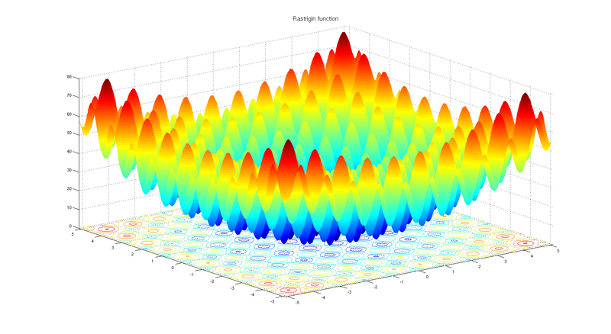
Meta Heuristics
A metaheuristic is a high-level problem-independent algorithmic framework that
provides a set of guidelines or strategies to develop heuristic optimization algorithms.

This area addresses to find best alternatives among given set of solutions of a particular problem. For this purpose, many optimizations techniques have been developed to find best alternatives. According to our limited knowledge, there is not even a single technique available that can give best solution for all kind of problems. Therefore, different techniques are used to address different problems depending upon their nature. To develop optimization techniques, researchers observe natural phenomenon and convert it into algorithms. One of the prominent examples is Genetic Algorithm which is inspired by biological evolution. Ant Colony Optimization, as the name indicates, is inspired by ant colonies. There are many examples like Gray Wolf Optimization, Particle Swarm Optimization, Gravitational Search Optimization, etc.

Objective of your proposed work
Our Idea
We are willing to develop an optimization algorithm. Inspiration we are using is War Tactics. There is no algorithm that is inspired by war tactics according to our knowledge. For that purpose, we will be studying several war tactics and map it into algorithm and then we would compare our algorithm with following well known algorithms:
- Genetic Algorithm
- Particle Swarm Optimization
- Gray Wolf Optimization
- Teacher Learning Algorithm
- Gravitational Search Algorithm
In order to compare our algorithm with above mentioned algorithms, we are willing to develop an application that would be able to compare these algorithms (Above algorithms can be changed). User can choose a particular algorithm and set its parameters and similarly, user can choose second algorithm as well and then their comparison will be shown in the form of graph. We would also test our algorithm on benchmark functions. (these would be mentioned is SRS document)

Significance of our work
- The proposed algorithm is based on war tactics and war strategies.
With the help of our work, many engineering problems like
- Automotive design
- Vehicle routing problem
- Welded beam design
Can give optimized solution
Our work will be shaped into publishable research paper.

Background and Justification
There are many nature inspired algorithms that are used to formulate many engineering, medical and industrial problems etc. There is algorithm on Wolves attacking, Dolphin echo-location, Tornedo, Whirlpool, Particle Swarm, Whale, Lion, Cuckoo, Bat etc. As far as we understood from these algorithms, every phenomenon in itself is based on optimization. These algorithms provoked an idea to design a new algorithm on a phenomenon on which no algorithm has been mapped mathematically. This thought led us to design an algorithm or War Tactics (tactics that are used in Battlefield).

Project Scope

Functional Requirements

Requirements id | Requirement Statement | Provide/Not Provide | Comment
FR001 | System shall be able to display list of all available algorithms. | Provide
FR002 | System shall be able to provide facility to select two algorithms for comparison. | Provide
FR003 | System shall be able to provide facility to select bench mark function as a comparison parameter. | Provide
FR004 | System shall be able to provide statistical results of comparison of algorithms. | Provide
FR005 | System shall be able to present histograms based on compared algorithms. | Provide
FR006 | System shall provide facility to see data and control variables used in algorithms.  . | Provide
FR007 | System shall provide facility to set and tune control variables for algorithms. | Provide
FR008 | System shall provide facility to update and tune control variables for algorithms. | Provide
FR009 | System shall not be able to import new Algorithm as Algorithms are in hardcoded form. | Not Provide
FR010 | System shall not be able to upload benchmark functions other than those that are built in. | Not Provide

Learning Outcomes
- We will be able to model real-life problems as optimization problems.
- We will be able to choose a solution method appropriate to the characteristics of a given problem and obtain a solution.
- We Will be able to demonstrate the action of optimization methods by solving illustrative problems on paper.
- We will be able to implement optimization methods yields problems in numerical linear algebra.

References
- The section should contain references of books, journals, magazines and websites consulted for the proposed work.
- You may provide the names of the people and their contact information that you have consulted >

